Introduction:

As noted by a number of media[1], hospitals across the U.S. are in the trend of merger and acquisition. This is sad news for many communities, especially those impoverished ones. Local community hospitals, after being acquired by a big healthcare brand name, are forced to shut down owing to a short of revenue. These hospitals in underprivileged areas have for a long time operated in deficit budget status, since patients admissioned are usually sponsored by government-backed insurance packaged, i.e. Medicare or Medicaid, or they don’t have healthcare insurance at all and are highly probable to default payment for healthcare services. A shortage of revenue will in turn hurt these hospitals’ ability to advance research and provide good quality healthcare services. In the end, they are forced to shut down and their closure means the local communities lose access to healthcare at all. On the other hand, large complex hospitals, owing to their ability to provide complicated medical services and attract affluent commercial insurance beneficiaries, generate sustainable cash flow. They are flexing muscles in the acquisition process by driving smaller hospitals out of business and consolidating their monopoly power in the healthcare market. In turn, they advance medical research and attract a larger number of wealthy patients. To put the trend in a more general social economic background, the U.S. has seen a shrinkage in middle-class size and a polarized income level in the past 40 years. The merger and acquisition trend in the healthcare industry may as well reflect the general social movement in the U.S..

Part 1 Introduction:

In this case, we will be exploring the Inpatient Data publicized by Vermont State and investigate how big and rich players exercise monopolistic power in the market. In particular, we want to test whether in more complex procedures among the Major Diagnostic Categories MDCs the larger hospitals attract more of the well paid Commercial insurance patients and fewer government paid Medicare beneficiaries. To do that, we will construct four Origin-Destination matrices to model the referral patterns among hospitals, including the big and the small ones, in Vermont. Elements on the diagonal line of any one matrix show the number or percentage of the care that is rendered with no referral involved. In the first matrix, we will be investigating the local treatment and referral percentage of hospitals in circulatory system treatment (MDC code: 5) for commercial insurance beneficiaries, which is believed to be a high-end care. In the second, we will be looking at the market of the same care for government-sponsored insurance beneficiaries. If the claim reported by CNBC holds true, we shall see that the ‘magnet’ hospital, University of Vermont Health Center, located in the Burlington area will admit a large number of commercial insurance beneficiaries in this MDC category by referrals from other hospitals; whereas, it will absorb fewer patients with government-sponsored insurance. In the third and fourth matrix, we will be looking at the local treatment and referral percentage of hospitals in musculoskeletal care (MDC code: 8), which does not require highly specialized staff and super fancy technology. Since treatment for illness in this category does not generate large cash flow, we expect to see lower referral rate from community hospitals to University of Vermont Health Center, however, we expect to see that University of Vermont Health Center will have a large market share for musculoskeletal treatment in the first place, owing to its monopolistic status in the region.

Before we dive into the O-D matrices, we will first calculate the HHI Index for the five regions in Vermont based on records and charges respectively to examine the market share of each region’s hospitals. The results we calculated are shown below:

*Table 1 HHI index based on records*

|  |  |
| --- | --- |
| **RR** | **HHI** |
| RR1 | 6584.52 |
| RR5 | 5811.77 |
| RR2 | 5809.22 |
| RR3 | 5022.87 |
| RR4 | 2606.19 |

*Table 2 HHI based on charges*

|  |  |
| --- | --- |
| **RR** | **HHI** |
| RR1 | 8058.97 |
| RR5 | 6817.21 |
| RR2 | 5941.76 |
| RR3 | 5025.60 |
| RR4 | 2567.37 |

The results came as no surprise, since RR1 represents the Burlington area where University of Vermont Health Center is located. As a result, we see a significantly higher HHI value for healthcare providers in RR1 either based on patient records or charges.

We also calculated the market share of each hospital based on records and charges respectively in Vermont to examine the monopolistic pattern on the hospital level. The results are shown below:

*Table 3 Market share of each hospital based on records*

|  |  |  |
| --- | --- | --- |
| **RR** | **hum2** | **market share** |
| RR1 | 5 | 0.80 |
| RR1 | 1 | 0.13 |
| RR1 | 9 | 0.07 |
| RR2 | 6 | 0.70 |
| RR2 | 4 | 0.30 |
| RR3 | 2 | 0.53 |
| RR3 | 3 | 0.47 |
| RR4 | 10 | 0.29 |
| RR4 | 12 | 0.29 |
| RR4 | 15 | 0.28 |
| RR4 | 11 | 0.12 |
| RR4 | 14 | 0.02 |
| RR5 | 8 | 0.70 |
| RR5 | 16 | 0.30 |

*Table 4 Market share of each hospital based on charges*

|  |  |  |
| --- | --- | --- |
| **RR** | **hnum2** | **Market share** |
| RR1 | 5 | 0.89 |
| RR1 | 1 | 0.06 |
| RR1 | 9 | 0.05 |
| RR2 | 6 | 0.72 |
| RR2 | 4 | 0.28 |
| RR3 | 3 | 0.54 |
| RR3 | 2 | 0.46 |
| RR4 | 10 | 0.32 |
| RR4 | 12 | 0.26 |
| RR4 | 15 | 0.24 |
| RR4 | 11 | 0.16 |
| RR4 | 14 | 0.01 |
| RR5 | 8 | 0.80 |
| RR5 | 16 | 0.20 |

As highlighted in the two tables above, hospital 5, 6 and 8, which are University of Vermont Medical Center, Central Vermont Hospital and Rutland Regional Medical Center, have market share values of more than 0.70, compared to the values of lower than 0.40 for the rest. The contrast of market share values show disparity between the two cohorts, i.e. the monopolistic pattern. Moreover, it should be noted that on either record or charge basis, University of Vermont Medical Center ranks the top in terms of market share. As for the reason why the University of Vermont Medical Center dominates the healthcare market in Vermont, we believe that the ability to provide comprehensive and lucrative medical services, especially in fields of heart, brain, and tiny blood vessels is a vital factor. Patients who can afford the services while finding no other comparable good-quality healthcare services in the state will then transfer to the ‘magnet’ hospital and bring a huge amount of revenue. In turn, the hospital will be able to advance its research and provide better training for its medical students, and thus obtain more superiority over hospitals in the state.

By showing the monopolistic pattern of the healthcare industry in terms of market share, we would like to further investigate how patient referrals indicate the pattern as well by constructing 8 pairs of O-D matrices.

The following is the first pair of O-D matrices, in which we will be investigating the local treatment and referral percentage of hospitals in circulatory system treatment (MDC code: 5) for commercial insurance beneficiaries.

Circulatory System Treatment (MDC code: 5) For Commercial Insurance Beneficiaries:[2]

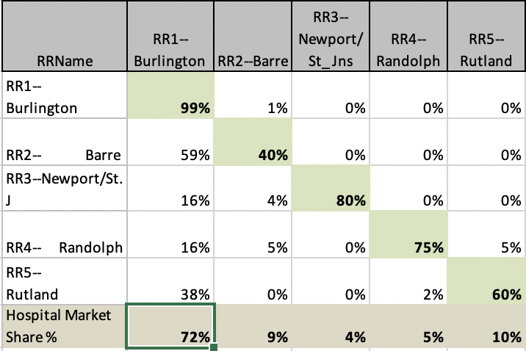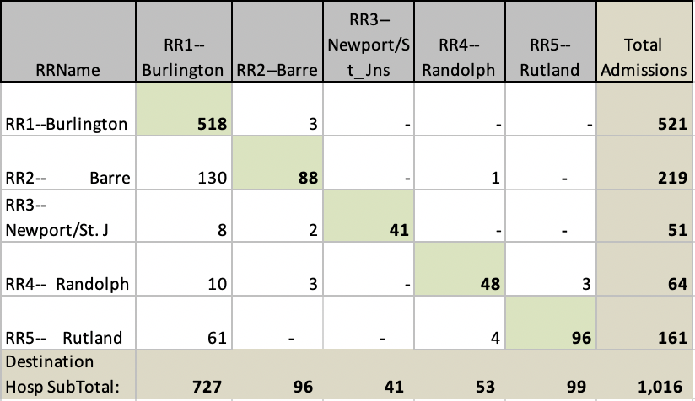

As manifested in the percentage matrix on the right side, hospitals in the Burlington area (area code: RR1) takes 72% of the total market share for circulatory system treatment. Though not explicitly shown, it’s not hard to guess that the University of Vermont Medical Center in the Burlington area takes a large slice of the 72% market share. Moreover, hospitals in this region are undoubtedly the top target destinations for patient referrals from other regions. It is safe to conclude that hospitals in this region, namely, the University of Vermont Medical Center, hold unchallenged superiority in the circulatory system care market for commercial insurance beneficiaries.

Let’s then look at the pattern of the same category of healthcare for government-sponsored insurance beneficiaries:

Circulatory System Treatment (MDC code: 5) For Government-Sponsored Insurance Beneficiaries:

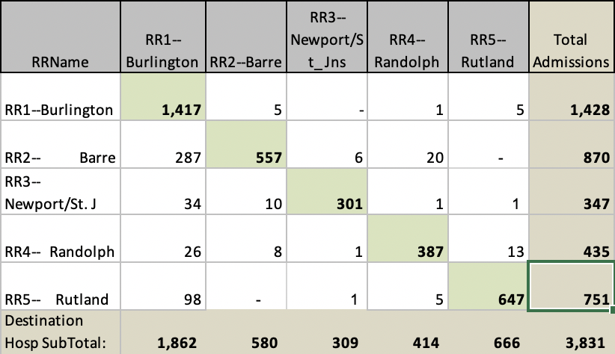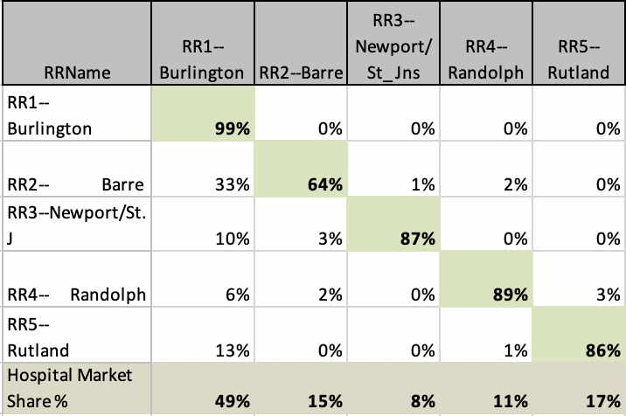

The pattern confirms the claim held by CNBC that large and complex players in the healthcare market are more likely to admit patients with commercial insurance coverage while this group of people can afford the fancy and expensive treatment provided by the large and complex hospitals. As shown in the matrix on the right hand side, hospitals in each region are more probable to keep the patients within, all with a probability of more than 60%. Moreover, the market share taken by hospitals in RR1, namely the University of Vermont Medical Center, is lower than 50%, though the market share still establishes the ‘magnet’ hospital as the superior power in the market, compared to the market share of 72%, it is considerably lower.

Let’s now look at the pattern of a different category of healthcare (musculoskeletal care, MDC code: 8) for commercial insurance beneficiaries:

Musculoskeletal (MDC code: 8) For Commercial Insurance Beneficiaries:

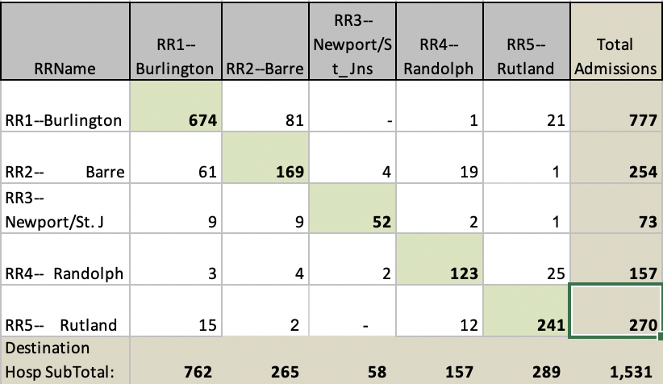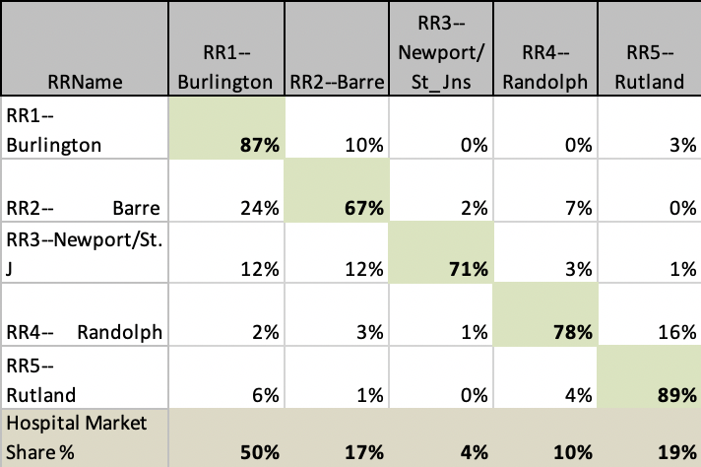

Musculoskeletal treatment is believed to be a “light” treatment compared to circulatory system care, while the former does not require super fancy technology nor highly specialized staff to perform complicated and over-priced operations. In another word, patients belonging to this category are more likely to recover in local small hospitals than patients who suffer from circulatory system issues. As a result, they will not seek advanced treatment in large hospitals such as University of Vermont Medical Center. Meanwhile, treatments in this category do not generate large cash flows, and are less enticing to large and complex players who look for more profitable deals. Consequently, the Burlington area, where the University of Vermont Medical Center sits, does not have as large a market share as it has for the commercial insurance beneficiaries’ circulatory system care market. Though it still takes a half the market and ranks as the top one target for patient referrals from neighboring areas, it dispatches roughly 10% patients to other areas as well. Moreover, hospitals in other regions tend to keep patients in house, as all these regions have a rate of more than 65% to keep patients in house.

Finally, let’s examine the pattern of musculoskeletal care (MDC code: 8) for government-sponsored insurance beneficiaries:

Musculoskeletal Care (MDC code: 8) For Government-Sponsored Insurance Beneficiaries:

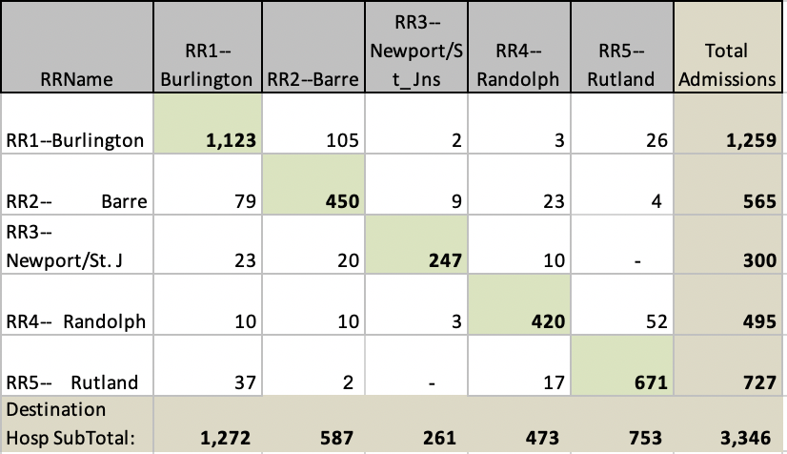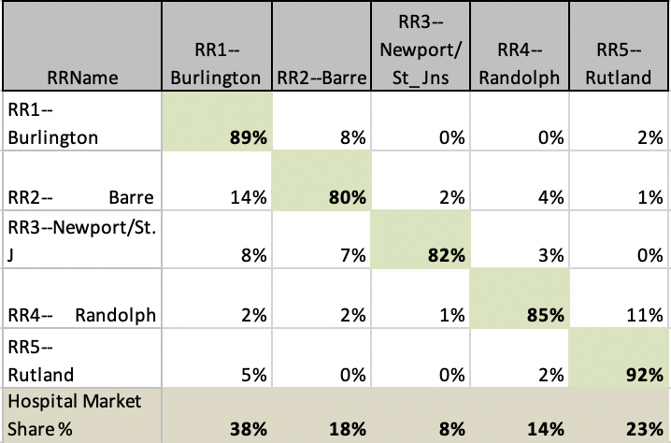

When it comes to the treatment of musculoskeletal issues for government-sponsored insurance beneficiaries who do not have a deep pocket, big and complex hospitals show less interest. Hospitals in the Burlington area take only 38% of market share while hospitals in all regions have a rate of keeping patients in house for more than 80%. Though the “magnet” hospital still leads the market share, however, its edge is not as significant as in the case of the healthcare market for the wealthy with circulatory system issues.

Conclusion:

Results generated by exploring the Vermont inpatient dataset suggests that the claimation made by CNBC and a few other medias is true: after some time of market consolidation, large players in the healthcare have an upper hand to provide more advanced and expensive to the upper-middle class who for the most part are covered by good-quality commercial insurance packages. The ability to make a profit on the patients will in turn keep these large players in dominance over small community hospitals. A large number of hospitals in the latter category have been driven to bankruptcy despite their importance in local communities.

It is also reported that some state governments have realized this problem, however, they have failed to provide an adequate solution. Their efforts have been too few and too late.[3] Maybe only a structural change on the federal level and a recognition of healthcare as basic human right rather than a business can prevent the healthcare system from further heading south, which will certainly be a bittering process.

1. CNBC Report: Why U.S. Hospitals Are Closing? <https://www.youtube.com/watch?v=18kxPz4Z_g8>
2. All matrices have excluded out-of-state patients and referrals to serve the purpose of examining in-state market patterns only.
3. <https://www.bizjournals.com/boston/news/2019/09/20/new-hampshire-ag-blocks-partners-acquisition-over.html>

   <https://www.bostonglobe.com/business/2015/01/29/partners/s9TxpYCBakjPN6pDbBFHGL/story.html>